Web Sys Quiz 2 Screenshots

Login Page (login.php):


User is not in database (register.php):


User tries to create an account with an existing username:
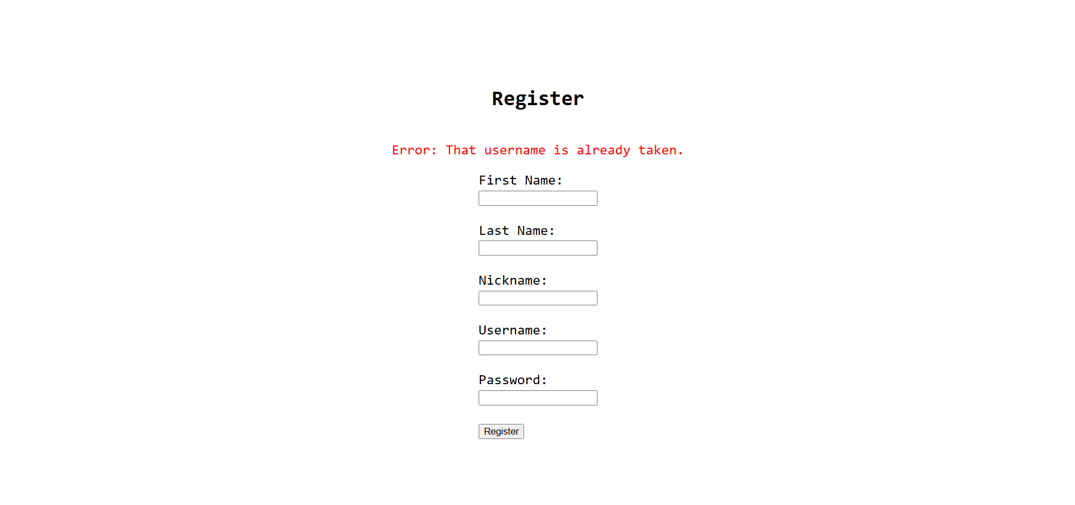

Incorrect Password for a Username that is in the Database:


Successful Login (index.php):


Project.php:
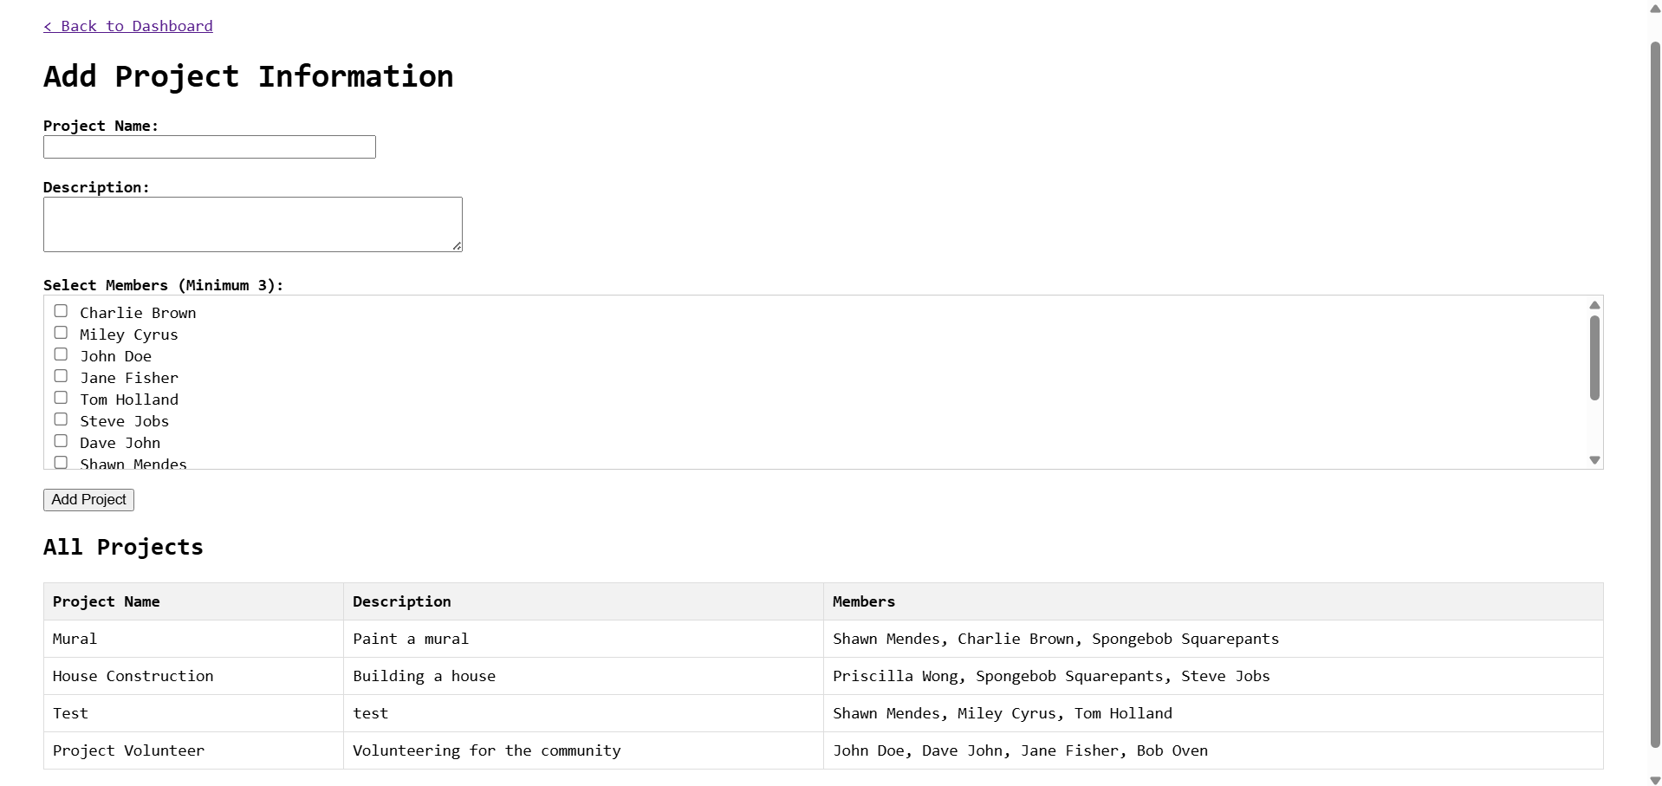

Adding a new project:
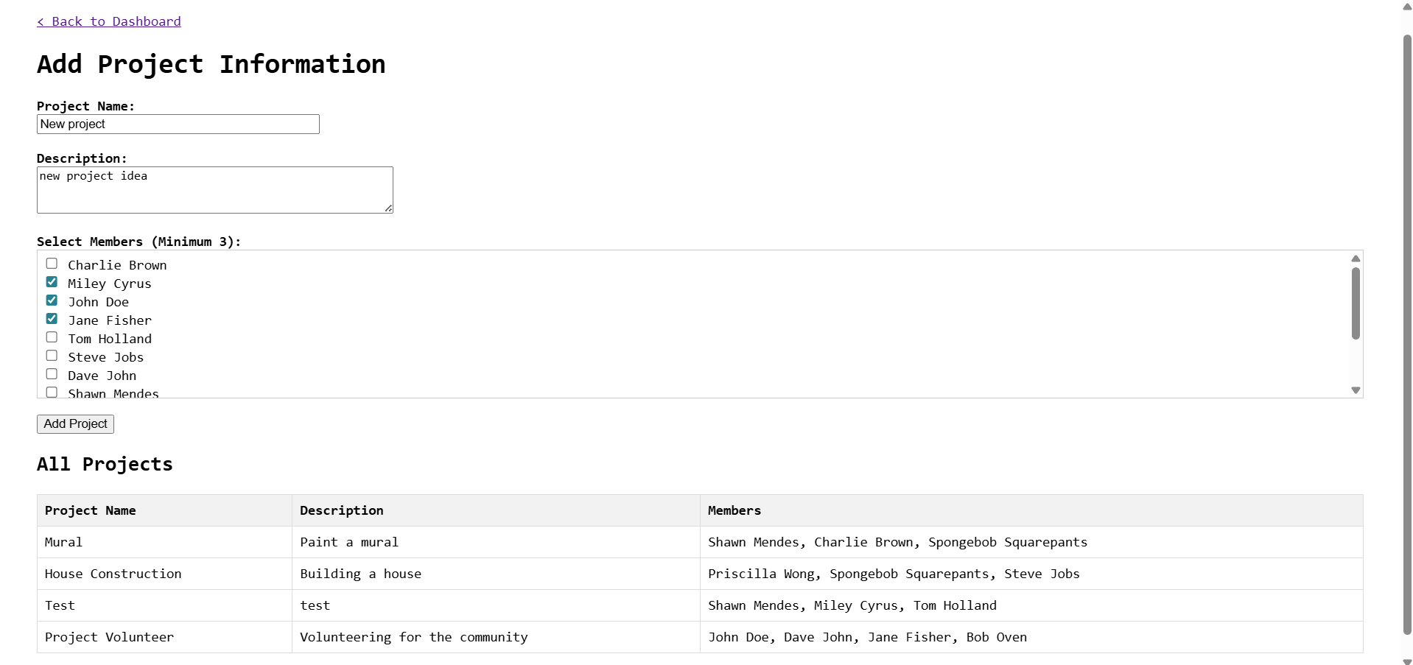

Successfully added project:
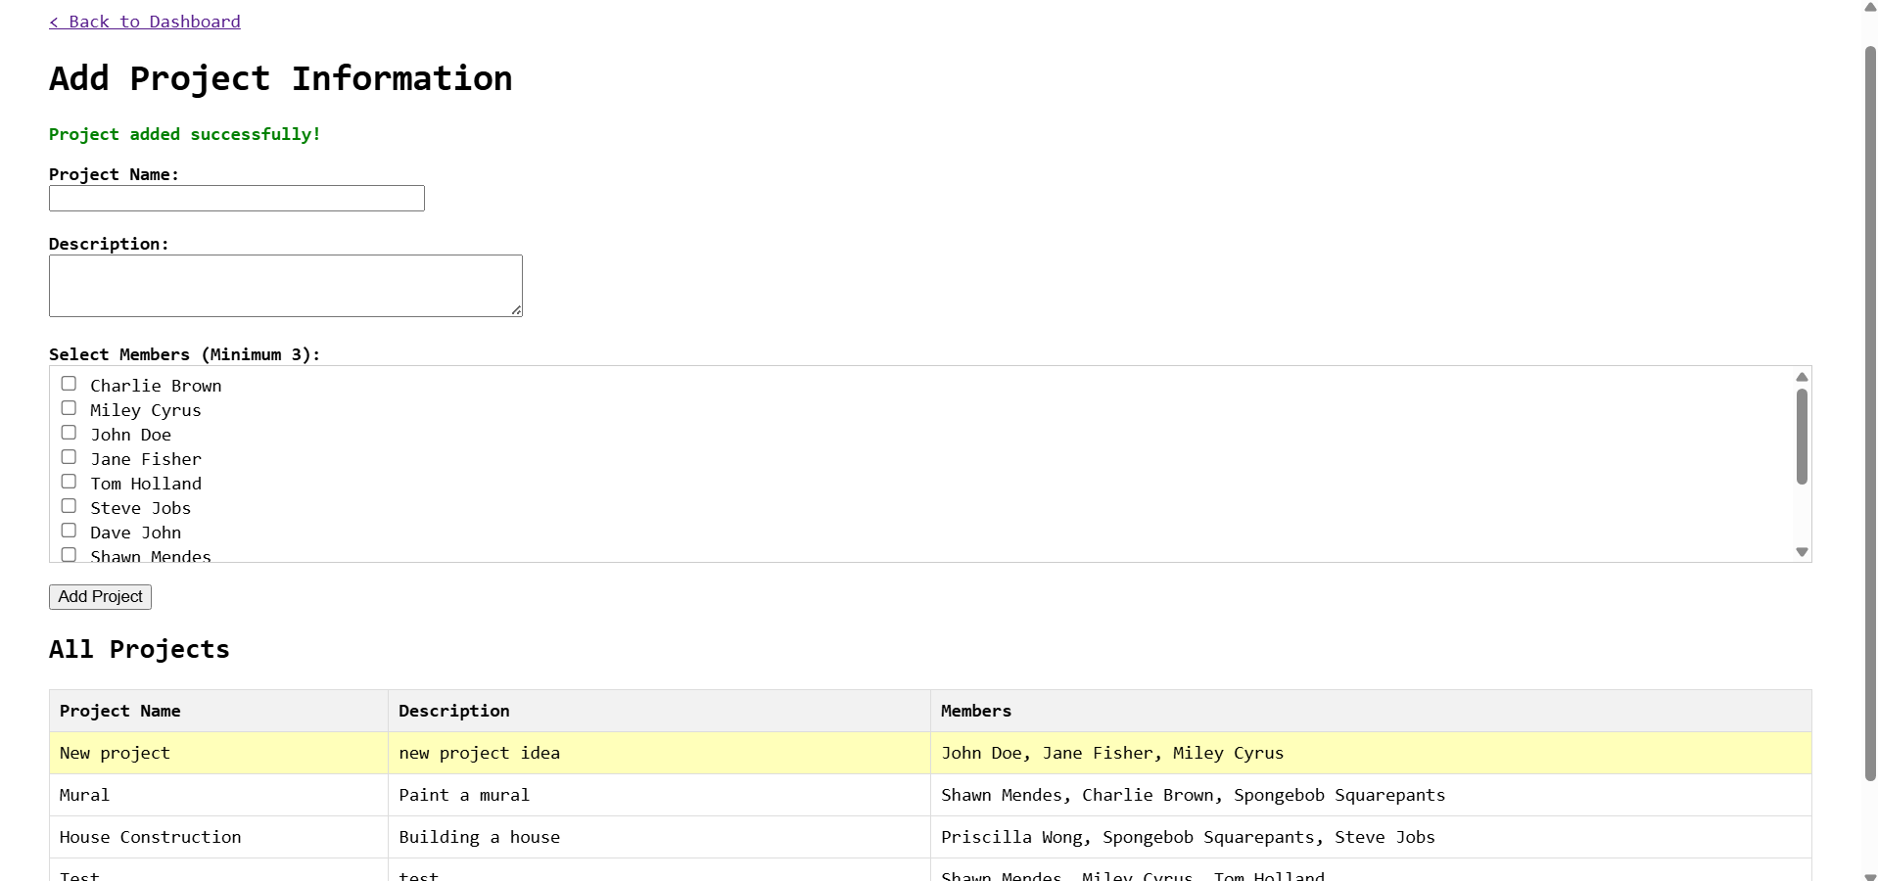

Error when creating project:
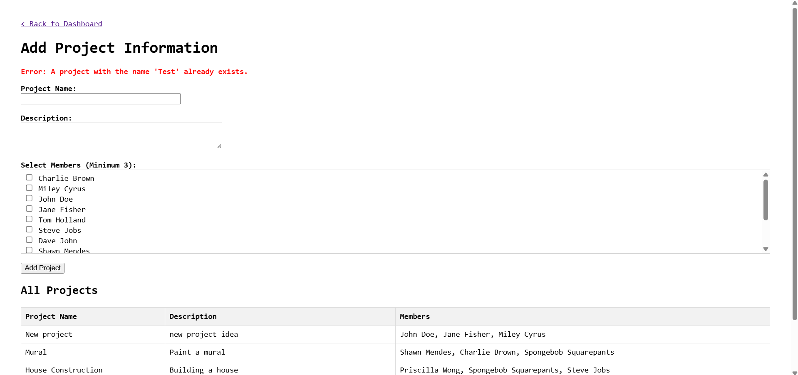

PhpMyAdmin Screenshots

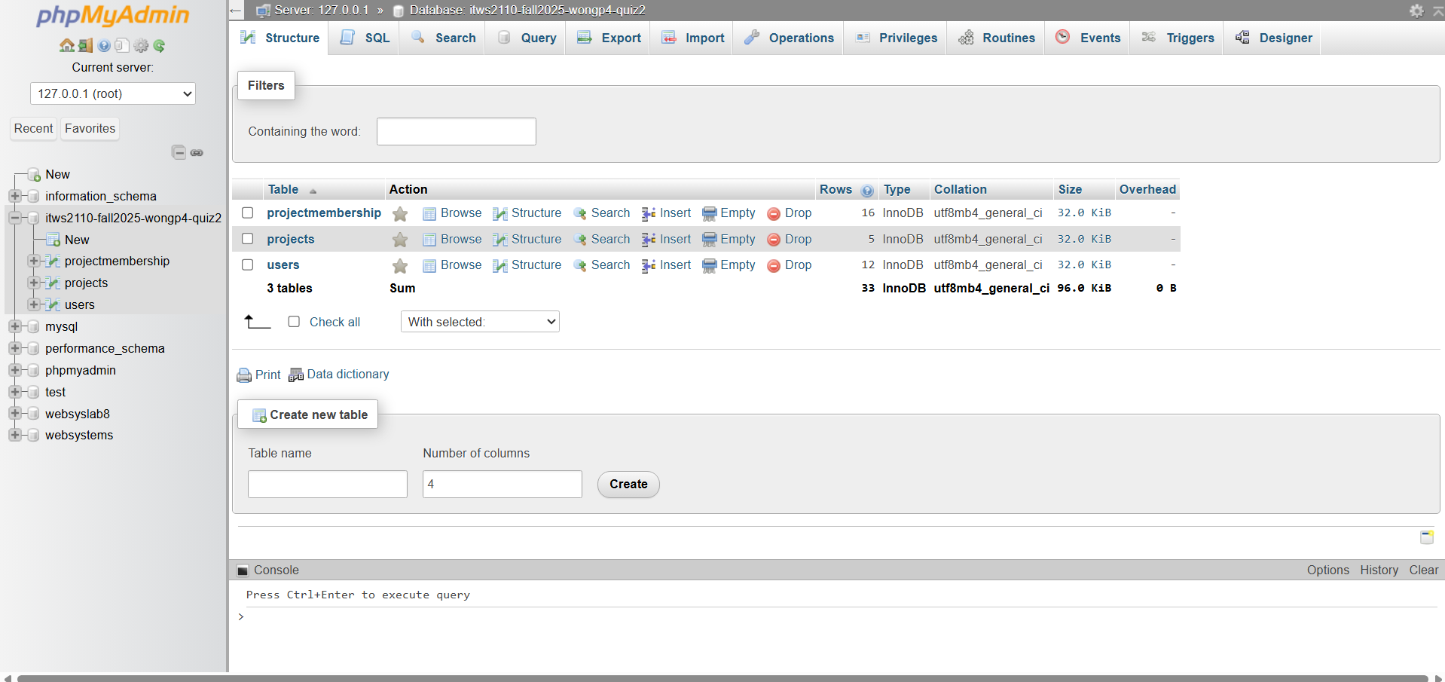
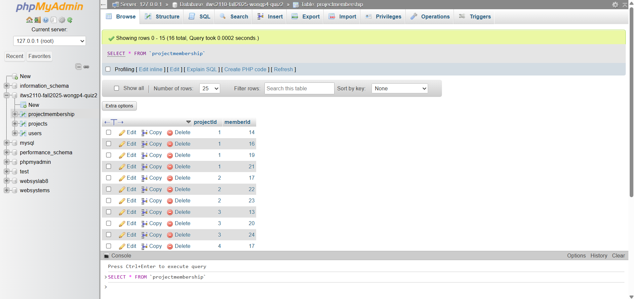

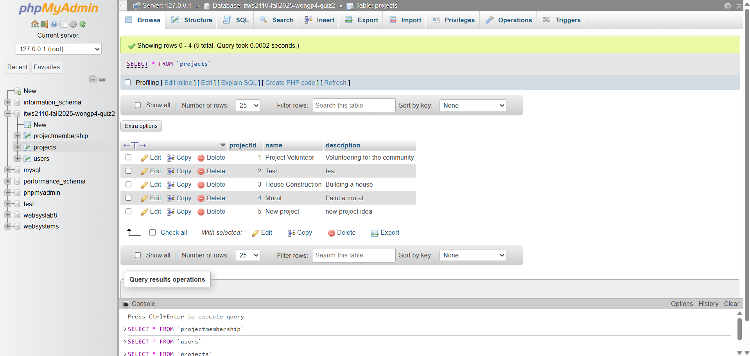
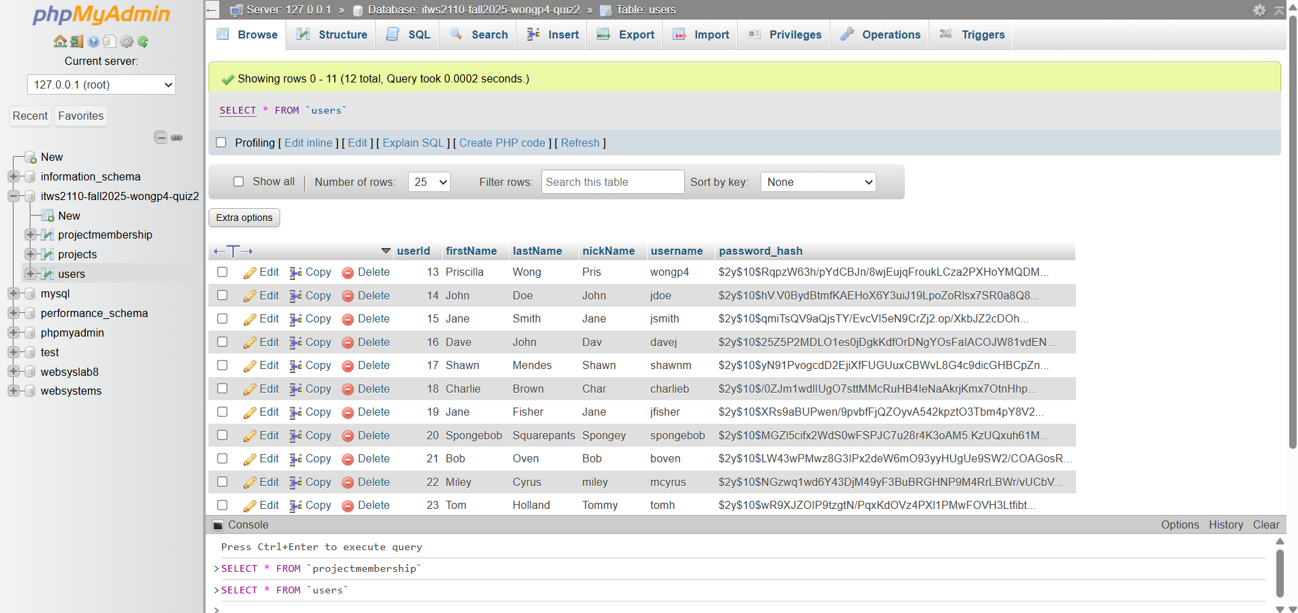

Database Setup

CREATE DATABASE IF NOT EXISTS `ITWS2110-Fall2025-wongp4-Quiz2` DEFAULT CHARACTER SET utf8mb4 COLLATE utf8mb4_unicode_ci;
USE `ITWS2110-Fall2025-wongp4-Quiz2`;

CREATE TABLE IF NOT EXISTS users (
userId INT AUTO_INCREMENT PRIMARY KEY,
firstName VARCHAR(100) NOT NULL,
lastName VARCHAR(100) NOT NULL,
nickName VARCHAR(100),
username VARCHAR(100) NOT NULL UNIQUE,
password_hash VARCHAR(255) NOT NULL
) ENGINE=InnoDB;

CREATE TABLE IF NOT EXISTS projects (
projectId INT AUTO_INCREMENT PRIMARY KEY,
name VARCHAR(255) NOT NULL UNIQUE,
description TEXT
) ENGINE=InnoDB;

CREATE TABLE IF NOT EXISTS projectMembership (
projectId INT NOT NULL,
memberId INT NOT NULL,
PRIMARY KEY (projectId, memberId),
FOREIGN KEY (projectId) REFERENCES projects(projectId) ON DELETE CASCADE,
FOREIGN KEY (memberId) REFERENCES users(userId) ON DELETE CASCADE
) ENGINE=InnoDB;

